Name
Instructor’s name
Course
Date
Landscape Proposal
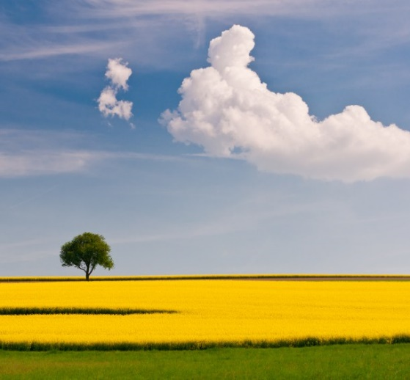

The photograph represents a vast grassland. Grasslands are critical areas because they provide suitable habitats for wild animals. These wild animals obtain food and shelter which are essential in their survival and population increase. There are many rules of composition which are dominant in this photograph. They include the rule of thirds, balancing elements, viewpoint and leading lines. The rule of thirds and viewpoint will assist me to create a spatial order in my painting. I will simplify my space by focusing on the crucial aspects of my painting. I will use attractive colours to design my painting. I will choose a complementary colour scheme consisting of blue and orange colours (Tang 2013).

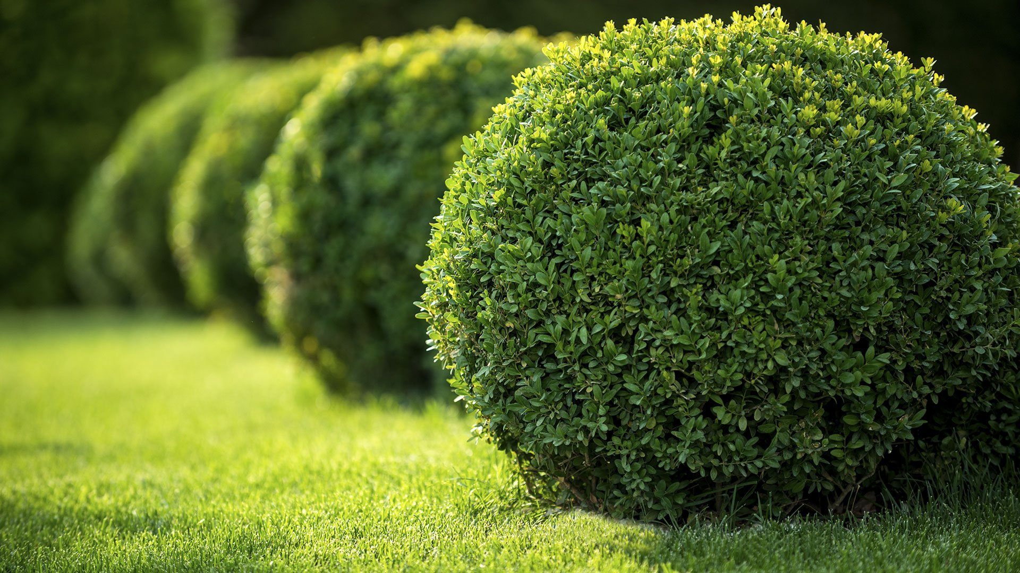

The photograph represents flowers that are used for decoration purposes. These flowers improve the physical appearance of an area making it more aesthetic. There are various rules of composition which are dominant in this photograph. They include cropping, balancing elements, the rule of thirds, background and leading lines. Cropping and balancing elements are the rules of composition which will assist me to create a spatial order in my painting. I will simplify my space by putting more emphasis on the item I wish to crop. I will use an analogous colour scheme in my painting as it will create a more atmospheric perspective. I will use three colours which include violet, green and orange (Rhyne 2016).

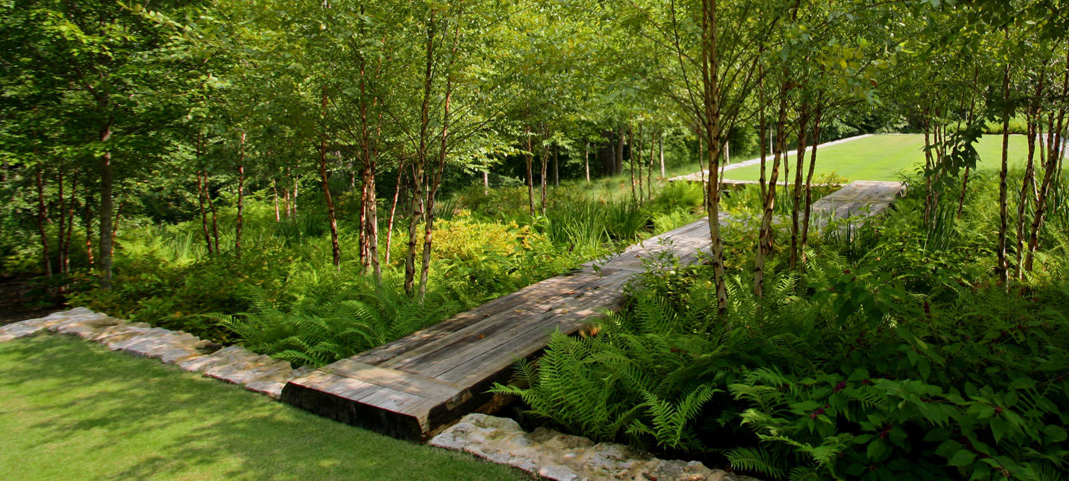

The photograph represents mixed types of vegetation including trees which are significant in preserving the beauty of nature. There are various rules of composition which are dominant in the photograph. They include depth, framing, viewpoint, background, the state of thirds and leading lines. I will use background, perspective and frame to create a spatial order in my painting. To simplify my space, I will focus on the most relevant items and disregard irrelevant items in my painting. I will use the split complementary colour scheme in my painting, and it will include three colours which are yellow, blue and violet (Westland 2012).

Works cited
Rhyne, Theresa-Marie. "Applying colour theory to digital media and visualization." (2016).
Tang, Xiaoou, Wei Luo, and Xiaogang Wang. "Content-based photo quality assessment." IEEE Transactions on Multimedia15.8 (2013): 1930-1943.
Westland, Stephen, et al. "Colour harmony." JAIC-Journal of the International Colour Association 1 (2012).

